INTERNSHIP REPORT ON

**BPU & CO.**

**- CHARTERED ACCOUNTANTS**

Submitted to Bengaluru City University



In partial fulfilment for the award of B.COM Degree

|  |  |
| --- | --- |
| Student | Mentor/Supervisor |
| Name: | Name: |
| Reg. No: | Signature: |
| Signature: |
| Date: | Date: |

|  |  |  |  |
| --- | --- | --- | --- |
|  | Project | Vice- Voce | Total |
| Max. Marks | 60 | 40 | 100 |
| Marks Allotted |  |  |  |
| Name of examiner |  | Sign: |  |

# EVALUATION OF INTERNSHIP REPORT

For submission to Bengaluru City University

**Evaluation Summary**

# BPU & CO

**- CHARTERED ACCOUNTANTS**

# CERTIFICATE

This is to certify student of Ⅵ semester BBA bearing REG NO. at **VIJAYA COLLEGE**, Bengaluru, has completed her 4 weeks of organizational study at our organization from **26th MARCH 2024** to **26th APRIL 2024.**

Name of the student has collected the required data and exhibited good discipline and completed the assigned tasks as required during the period.

We wish her good luck in all future endeavors.

**Place:** Bengaluru

**Date:** 16/06/2024 **For Name of the organization**

Signature with seal

Authorized Signatory

**COLLEGE CERTIFICATE**

This is to certify that this Internship report on **“BPU & CO – Chartered Accountants”** is carried out by

He has successfully completed her 4 weeks organizational study.

The Internship report is submitted to the Bengaluru City University in the academic year 2023-2024, in partial fulfillment for successful completion of Ⅵ semester BBA and award of

Bachelor of Business Administration of Bengaluru City University.

**Place:** Bengaluru **PRINCIPAL**

**Date:** 16/06/

# SUPERVISOR’S CERTIFICATE

This is to certify that the content of this report on **“BPU & CO – Chartered Accountants”** is carried out by student of Ⅵ semester B.COM, bearing REG NO.is a bonafide work carried out by the student under my supervision during the academic year 2023-2024 in partial fulfillment for the completion of Ⅵ semester B.COM of

Bengaluru City University.

This Internship Report is an original work carried out by the said student and there is no plagiarism. This Internship report has not been submitted for the award of any other degree in this institution or any other institution.

**Place:** Bengaluru **Name of the Supervisor**

**Date:** 16/06/2024

# DECLARATION BY STUDENT

I hereby declare that this Internship report on “Organizational study with particular reference to is an original record of my experience while conducting the internship study at

**BPU & CO – Chartered Accountants**.

The organizational study was carried out by me, in partial fulfillment for the successful completion of Ⅵ semester B.COM of Bengaluru City University. This report is not submitted to any other university for the award of any degree.

**Place:** Bengaluru **Name of the Student**

**Date:** 16/06/2024 (

# ACKNOWLEDGEMENT

I am deeply indeed to sir for giving me an opportunity to carry out the organizational study at **BPU & CO – Chartered Accountants** and for giving vital support and guidance to complete this endeavor.

I would like to express my gratitude to our Principal for his constant support and encouragement.

I am extremely grateful to my Supervisor,

Associate Professor, Department of Commerce, for her support and timely guidance provided for the completion and preparation of this report.

This endeavor would not have been possible without the support of my parents. My special thanks to them.

I would also like to thank my friends for their encouragement and moral support throughout the work.

**Name of the Student**

|  |  |  |
| --- | --- | --- |
| **Chapter No.** | **Content** | **Page No.** |
| 1 | Introduction |  |
| 2 | Profile of the Organization |  |
| 3 | Functions/Operations of the organization |  |
| 4 | Learning, Outcomes,  Suggestions and Conclusion |  |
| 5 | Annexures:  • Log sheets |  |

# LIST OF CONTENTS

## 1. INTRODUCTION TO CHARTERED ACCOUNTANTS

Chartered accountants were the first accountants to form a professional accounting body, initially established in Scotland in 1854. The Edinburgh Society of Accountants (1854), the Glasgow Institute of Accountants and Actuaries (1854) and the Aberdeen Society of Accountants (1867) were each granted a royal charter almost from their inception. The title is an internationally recognized professional designation; the certified public accountant designation is generally equivalent to it. Women were able to become chartered accountants only following the Sex Disqualification (Removal) Act 1919 after which, in 1920, Mary Harris Smith was recognized by the Institute of Chartered Accountants in England and Wales and became the first woman-chartered accountant in the world.

Chartered accountants work in all fields of business and finance, including auditing, taxation, financial and general management. Some are engaged in public practice work; others work in the private sector and some are employed by government bodies.

Chartered accountants’ institutes require members to undertake a minimum level of continuing professional development to stay professionally competitive. They facilitate special interest groups (for instance, entertainment and media, or insolvency and restructuring) which lead in their fields. They provide support to members by offering advisory services, technical helplines and technical libraries. They also offer opportunities for professional networking, career and business development.

In India, Chartered Accountants are regulated by the Institute of Chartered

Accountants of India (ICAI) which was established by the Chartered Accountants Act, 1949. Associate members of the ICAI are entitled to add the prefix CA to their names. Members who are in full-time practice, and have completed five years of practice, can use Fellow Chartered Accountant (FCA).

Entry to the profession can be made by taking the CA Foundation Course after completion of schooling (12th grade). To become a Chartered Accountant, one needs to clear all three levels of Chartered Accountancy course and the Article ship (Practical Training). A comprehensive 100 hours of information technology training and an orientation programme for soft skills development have to be completed before being articled. However, the CA certification is limited to the geographical boundary of India and is not valid in countries that follow different standards of accounting practice. After clearing of CA final examination, one may apply for membership to ICAI.

# 2. PROFILE OF THE ORGANISATION

## BPU & CO – CHARTERED ACCOUNTANTS



BPU & CO is a firm of Chartered Accountants with a team of over 40 members possesses vast domain and industry expertise across IT services, banking, manufacturing, social impact businesses, insurance, investment banking, real estate, retail, and medium and small-scale enterprises. Collectively, the team has over 50 years of experience in management accounting, commercial contracting, management information systems, valuation and mergers & acquisitions, taxation, statutory and internal auditing, and assurances. The firm is associated with leading companies in their respective industry verticals and draws strength from the curiosity, courage, lateral thinking, collaboration, and open-mindedness of the team.

Specialization extends to Indirect Taxation, including Goods and Services Tax,

Customs, Foreign Trade Policy, and former Central Excise, Service Tax, and

Value Added Tax. Additionally, there is substantial experience in implementing Internal Controls (IFC) and IND AS for multinational corporations, conducting business valuations, and providing reconciliation and process automation services. Renowned for in-depth study, quality excellence, independence, value-added services, and client-focused orientation, the firm has successfully implemented virtual CFO models for various companies.

The team brings over 15 years of corporate experience across multiple finance functions, managing direct and indirect taxes, company law compliance, and foreign transaction compliance, along with financial planning and analysis, controllership, and business finance functions for small, medium, and large enterprises. End-to-end statutory and tax audits are handled for companies in diverse sectors, including ITES, healthcare, retail, e-commerce, banking, financial institutions, manufacturing, and co-operative societies. Services encompass performance forecasting, revenue and P&L presentations, periodic MIS preparation and circulation, MIS reviews with stakeholders, larger management reviews, and tracking actions to closure.

The firm excels in financial planning and analysis, cost reduction, and operational performance excellence. Specialization includes pricing and commercial negotiations, contract negotiations with customers and vendors, deal pricing and modeling, and pipeline and deal win-loss analytics. M&A support includes financial due diligence to assess feasibility, IRR, payback period, and synergy benefits, culminating in final deal proposals to senior management. With exposure to major ERPs like SAP, Tally, and Finacle, statutory and tax audits, corporate tax filing, and other statutory filings are managed for Indian and foreign entities. Additionally, the firm facilitates funding raising for start-ups and growing companies through debt and equity.

**MISSION:**

The mission is to provide timely, resultoriented solutions with quality and excellence, addressing client requirements and exceeding expectations to add value.

**VISION:**

The vision is to be recognized as trusted, reliable, and preferred financial and tax professionals in the region.

**VALUES:**

Ethical practices with independence and integrity are strongly upheld, with a keen interest in adopting automation to simplify clients’ compliance burdens.

## 3. FUNCTIONS OF THE ORGANIZATION

### INVENTORY/STOCK AUDITING

**Meaning of Auditing:**

Auditing is the meticulous process of meticulously examining an organization’s financial records to ensure they are not only accurate but also faithfully represent the entity’s financial position and operational activities. Given that these records originate internally, there exists a notable risk of manipulation by internal parties, whether through inadvertent errors or deliberate falsification, which constitutes fraudulent conduct. Auditing serves as a critical safeguard against such occurrences.

Furthermore, audits are indispensable in verifying that organizations adhere to pertinent accounting standards like International Financial Reporting Standards (IFRS), Generally Accepted Accounting Principles (GAAP), and other applicable guidelines. Compliance with these standards guarantees the consistency and reliability of financial reporting, fostering trust among stakeholders and facilitating informed decisionmaking.

In essence, auditing stands as a pivotal process ensuring the integrity, accuracy, and compliance of financial records, thereby fortifying organizational transparency and accountability.

**Meaning of Inventory Auditing:**

Inventory auditing is the process of verifying the accuracy of financial records by cross-referencing them with the actual physical inventory and related records. This process can be conducted by auditors or other responsible parties. It may involve straightforward tasks such as physically counting stock to ensure it aligns with the documented accounting records.

**Evidence in Auditing:**

Evidence holds a critical role in auditing as it serves multiple essential purposes. Firstly, it is indispensable for determining whether financial statements and records have been prepared in strict adherence to established standards and are devoid of significant errors. This verification process not only upholds the accuracy of financial reporting but also ensures transparency and supports the independence of audit reports. Auditors rely on evidence to validate the authenticity and reliability of financial records presented by organizations. It acts as a foundation to either substantiate the financial information provided or to uncover discrepancies that could signal errors or potentially fraudulent activities perpetrated internally. In essence, evidence in auditing functions as a cornerstone for ensuring the

integrity of financial information, bolstering stakeholder confidence, and facilitating informed decision-making.

**Importance of Inventory Auditing:**

* **Verification of Accuracy**: Auditing inventory ensures that the financial records accurately reflect the physical inventory held by the business. This verification is crucial for maintaining the integrity and reliability of financial statements.

* **Critical Evidence Gathering**: Inventory audits provide essential evidence for auditors, particularly in industries like manufacturing or retail where inventory represents a significant portion of assets or capital. This evidence supports the accuracy and completeness of financial reporting.

* **Assessment of Asset Value**: Audits not only confirm the quantity of inventory but also evaluate its quality and condition. This assessment is necessary to ensure that the inventory’s value is correctly represented in the financial records and statements.

* **Compliance and Control**: Auditing inventory helps ensure compliance with accounting standards and internal controls. It verifies that inventory management practices are in line with established policies and procedures, reducing the risk of errors or fraud.

* **Enhanced Decision-Making**: Accurate inventory audits provide stakeholders with reliable information for making informed decisions. Investors, creditors, and management rely on audited inventory figures to assess the financial health and performance of the business.

Auditing inventory is integral for verifying accuracy, gathering critical evidence, assessing asset value, ensuring compliance, and supporting informed decision-making within manufacturing and retail businesses. It safeguards against financial misstatements and reinforces the credibility of financial reporting processes.

**Procedures of Inventory Audit:**

1. **ABC Analysis:** 
   * Segmentation of inventory into high-value, mid-value, and low-value categories.
   * Enables focused tracking and management based on value and volume.

1. **Analytical Procedures:** 
   * + Examination of inventory using financial metrics like gross margins, inventory turnover, and historical costs.
     + Provides insights into inventory efficiency and financial health.

1. **Cut-off Analysis:** 
   * + Temporarily halting inventory transactions during physical counts.
     + Prevents errors in counting by ensuring all transactions are properly recorded in the correct period.

1. **Finished Goods Cost Analysis:** 
   * + Valuation of finished goods inventory at the end of an accounting period.
     + Crucial for manufacturing businesses to accurately reflect production costs.

1. **Freight Cost Analysis:** 
   * + Assessment of shipping expenses associated with transporting inventory.
     + Ensures proper inclusion of freight costs in inventory valuation.

1. **Matching:** 
   * + Verification of inventory shipped against financial records.
     + Confirms accuracy in recording inventory movements and costs.

1. **Overhead Analysis:** 
   * + Evaluation of indirect costs (e.g., rent, utilities) included in inventory costs.
     + Ensures overhead costs are correctly allocated to inventory.

1. **Reconciliation:** 
   * + Resolution of discrepancies identified during the audit process.
     + Corrects errors and ensures accuracy in financial reporting.

These audit procedures collectively ensure that inventory records are accurate, properly valued, and compliant with accounting standards, enhancing transparency and reliability in financial reporting for businesses.

### VOUCHING

**Meaning of Vouching:**

Vouching is a fundamental auditing procedure where an auditor meticulously inspects documentary evidence to verify and substantiate transactions recorded in financial records. This critical process ensures that all receipts and payments are accurately accounted for, guarding against fraudulent activities.

By vouching, auditors gather substantive evidence to ascertain the completeness, accuracy, and validity of transactions. This scrutiny not only reveals the genuineness of transactions but also forms the basis for verifying assets and liabilities. Auditors bear the responsibility of meticulously validating vouchers to ensure the accuracy of financial reporting. Vouching, therefore, stands as the cornerstone of the auditing process, providing essential assurance and integrity to financial statements.

**Characteristics of Vouching:**

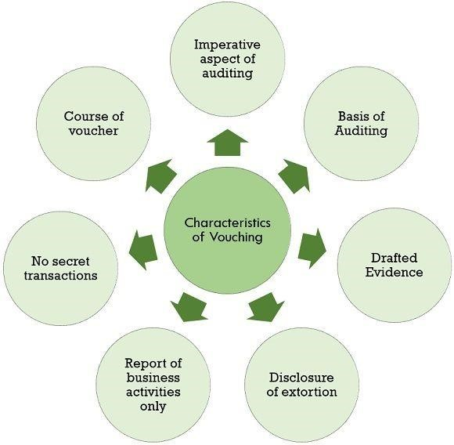

1. **Imperative Aspect of Auditing:**
   * Vouching is crucial in auditing, reinforcing the auditor’s confidence in the authenticity of recorded transactions.
2. **Basis of Auditing:**
   * Serves as the basis for further audit procedures, ensuring the accuracy and fairness of the auditor’s subsequent work.
3. **Drafted Evidence:**
   * Vouchers provide documented proof that transactions genuinely occurred within the financial year.
4. **Disclosure of Extortion:**
   * Despite being signed by the owner, vouchers can reveal fraudulent transactions in the books of accounts.
5. **Report on Business Activities Only:**
   * Vouchers distinguish between business and personal transactions, ensuring only business-related transactions are considered in the profit and loss evaluation.
6. **No Secret Transactions:**
   * Vouchers ensure all business transactions are identified, preventing the concealment of any non-business activities.
7. **Course of Voucher:**

|  |  |
| --- | --- |
| •  •  •  •  •  •  •  •  •  • | • The date on the voucher confirms the transaction occurred within the current financial period.    **Importance of Vouching:**    **Classification** **Verification**: Vouching ensures that transactions are correctly classified and disclosed according to the organization’s accounting policies, maintaining consistency and transparency in financial reporting.    **Accuracy of Amounts**: It verifies that transactions are recorded with the correct amounts, preventing errors that could distort financial statements and mislead stakeholders.    **Entity Relevance**: Vouching confirms that transactions are relevant to the entity and occurred during the appropriate reporting period, ensuring the reliability and relevance of financial information.    **Verification of Occurrence**: It validates that recorded transactions actually took place, guarding against the inclusion of fictitious or unauthorized transactions in the financial records.    **Proper Account and Period**: Vouching ensures that transactions are posted to  the correct accounts and allocated to the appropriate accounting period, supporting the accuracy and completeness of financial reporting.    **Objectives of Vouching:**    To see that transactions & entries are properly recorded in the books of accounts.    To see that entries & transactions are properly authenticated by a reasonable person.    To see that transactions have been properly classified & disclosed in accordance with the accounting policies.    To see that no fraudulent transactions are recorded in books of accounts.    To see that all entries & transactions are supported by proper evidence.      16 |

## 4. LEARNINGS, OUTCOMES, SUGGESTIONS AND CONCLUSION

### INVENTORY/STOCK AUDITING



**Learning/Experience:**

* The renowned company, with a turnover of around 200 crores, recently conducted a stock audit.

* For easy identification, each product is assigned a unique barcode.

* The stock audit was carried out at multiple locations, providing valuable exposure and experience.

* A visit to the company's warehouse revealed a large inventory.

* Gained insights into the shipment process.

* The warehouse is organized into different departments based on their functions, including:
  1. Online Shipment Department
  2. Quality and Quantity Checking Department
  3. Various Packing Procedures Department
  4. Replacement Process Department, etc.

* Conducted physical verification of inventory.

* Prepared daily reports to document the stock audit findings.

**Outcome:**

* **Ensuring High Quality and Accurate Quantities:** It's crucial to thoroughly check both the quality and quantity of each product. This guarantees customer satisfaction and minimizes returns or complaints.

* **Conducting Cross-Verification of Inventory:** Regularly cross-verifying inventory helps prevent discrepancies, thereby reducing negative feedback and maintaining a reliable stock system.
* **Implementing Attractive and Secure Packaging:** Using proper, visually appealing, and secure packaging enhances the customer's unboxing experience and can increase customer loyalty and repeat purchases.

**INVENTORY AUDITING IN WAREHOUSE**

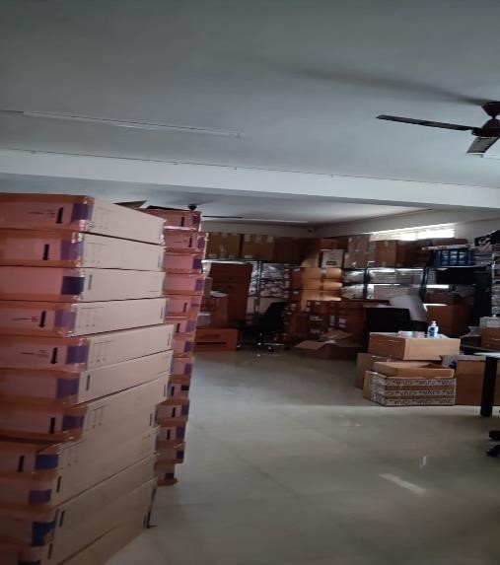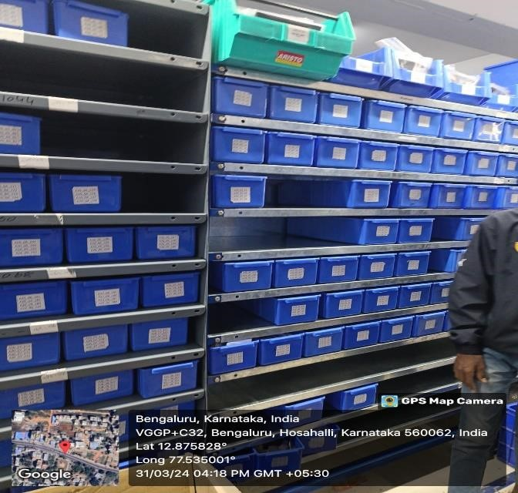

|  |  |  |  |
| --- | --- | --- | --- |
| |  | | --- | | **Stock Godown** | | |  | | --- | | **Packing department** | |

|  |
| --- |
| **Shipping department** |

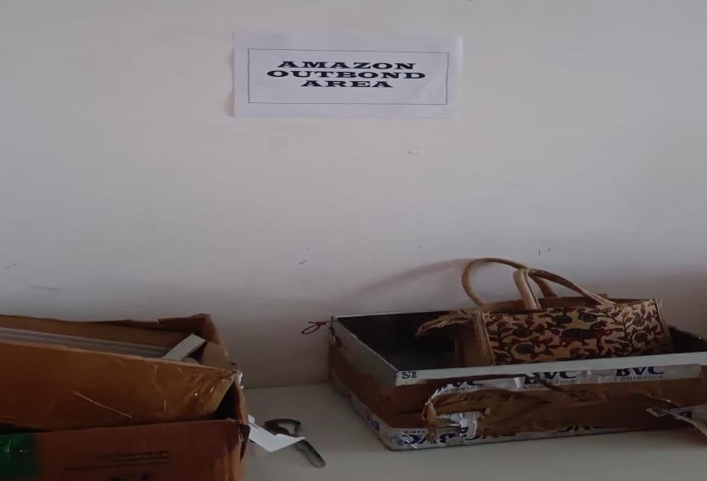

|  |  |  |
| --- | --- | --- |
|  | |  | | --- | | **List of Shipment** | |

|  |  |  |
| --- | --- | --- |
| |  | | --- | | **Verifying the stocks** | |  |

### VOUCHING

During my experience with vouching, which is the continuous part of stock auditing for the same company where we verified the expenses, I gained valuable insights.

**Learning/Experience:**

* 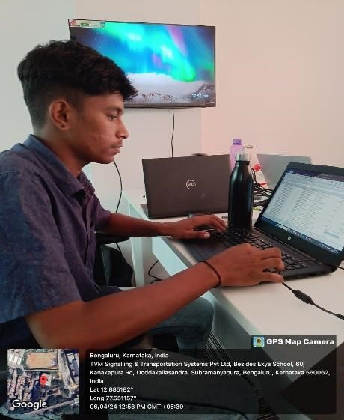Verified tangible assets, including purchase orders, invoices, and agreements.

* Acquired knowledge about different state GSTINs.

* Understood the distinctions between interstate and intrastate supply.

* Learned about the application of TDS at different percentages under sections 194I, 194J, and 194C.

**Outcome:**

* Enhanced accuracy in financial documentation and improved ability to verify and reconcile transactions. This skill ensures the integrity of financial records and compliance with company policies and regulations.

* 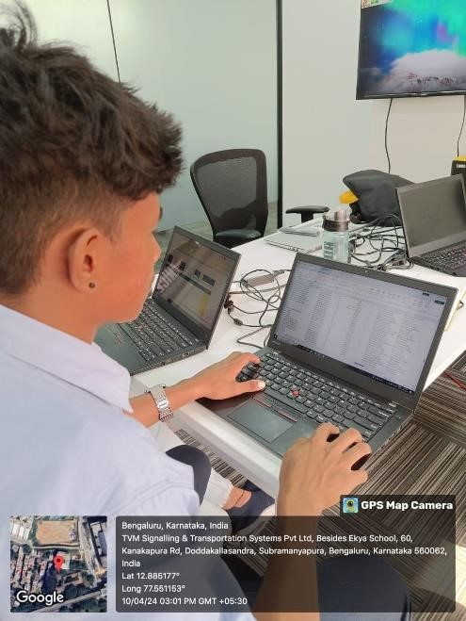Improved understanding of state-specific tax regulations and better management of GST compliance across different jurisdictions. This knowledge aids in accurate tax reporting and reduces the risk of non-compliance penalties.

* Ability to correctly categorize transactions for GST purposes, ensuring proper tax treatment and reporting.

* Enhanced competence in applying appropriate TDS rates based on the nature of payments.

* Additionally, I learned about the proper format of invoices and became familiar with the GST slab rates for various expenses.

# TYPES OF SOFTWARE LEARNED IN THE INTERNSHIP

## TALLY PRIME

**Meaning of Tally Prime:**

Tally Prime is a robust business management software designed to assist small and medium enterprises in efficiently managing various aspects of their operations, including accounting, inventory, banking, taxation, payroll, and more. As an upgraded version of the widely-used Tally ERP developed by Tally Solutions, tally Prime builds on its predecessor's success, offering enhanced features and a more intuitive user experience. This powerful tool streamlines business processes, enabling companies to operate more effectively and make informed decisions with greater ease.

**Learnings:**

Learning Tally Prime can provide a comprehensive understanding of various aspects of accounting and business management.

* Double-entry bookkeeping.

* Ledger creation and management.

* Posting Journal entries.

* Preparing Stock category, Stock group and Stock items.

* Goods and Services Tax (GST) compliance.

* Sales and purchase order processing.

* Creating and managing invoices.

* Managing receipts and payments.

* Cost centre and cost category management.

* Efficient navigation within Tally Prime.

* Customization of the interface to suit business needs.

* Shortcuts and productivity tips.

**Outcomes:**

* Learning Tally Prime equips users with essential skills for effective business management and financial administration, making it a valuable tool for accountants, business owners, and finance professionals.

* Learning Tally Prime results in more efficient, compliant, and profitable business operations, while also enhancing the professional capabilities of individuals using the software.

* Managing the ledgers, vouchers and financial statements enhances the accounting skills.

* Enhance career prospects in accounting and finance.

* In tally prime, various taxes can be accurately calculated and filed.

Overall, Tally Prime improves financial control, operational efficiency, and compliance, aiding in business growth.

.

# CONCLUSION

BPU & Co is an organization that fosters inter-departmental connections enhances operational efficiency. Sharing information across departments reduces bottlenecks and allows for the effective resolution of errors, promoting a more cohesive and productive work environment. This collaborative approach ensures that any issues can be promptly addressed, minimizing errors and optimizing overall performance.

Through my extensive experience in vouching as an integral part of stock auditing, I have acquired a wealth of knowledge and skills that have significantly enhanced my proficiency in financial auditing and regulatory compliance.

The comprehensive experience gained through stock auditing and vouching has significantly enhanced my skills in inventory management, financial documentation, and regulatory compliance. This holistic exposure has equipped me with the necessary knowledge and skills to effectively manage and audit inventory while ensuring financial accuracy and compliance. By implementing secure packaging, maintaining high-quality and accurate quantities, and understanding tax regulations, I am well-prepared to meet future challenges in the field. My practical inventory management skills, combined with a deep understanding of financial documentation, position me to contribute significantly to efficient operations and customer satisfaction in any organizational setting.

## 5. ANNEXURES

**INTERSHIP LOG SHEET**

**Student Name**:

**College Name**:

**Class**:

**University Register Number**:

**Organization Name and Address**

**Mentor/Guide Name**:

# THANK YOU